|  |  |  |  |  |
| --- | --- | --- | --- | --- |
| **WEEK** | **VALUE PROMISE** | **MEMORY VERSE** | **CHARACTER TRAITS** | **WORK HABIT** |
| **ONE** | “I choose to commit and work on time”. | Proverbs 22:6 | 1. Be accountable  2. Obedience  3. Be encouraging  4. Be responsible  5. Be faithful | A goal properly set is half way reached |

Proverbs 22:6 “Train up a child in the way he should go: and when he is old he will he not depart from it”.

**PERIOD 1**

Name: _________________________________________

Date: __________________________________________

School: _________________________________________

**Theme: Our Sub County/ Division.**

**Sub theme: Name of our sub- county / division.**

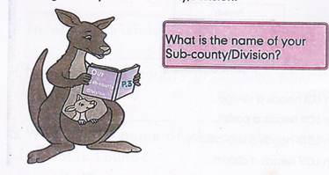Welcome to primary Three. You are going to enjoy learning about your Sub-county / Division.

A sub-county is an area made up of parishes and villages.

A parish is a group of villages

A county is an area made up of different homes.

A Village is an area made up of counties

A district is an area made up of districts.

**Naming and arranging our area in their order from smallest to the biggest.**

**Country**

**District**

**County**

**Sub county/ Division**

**Parish**

**Village**

A Chairperson LC I heads a village.

A Chairperson LC II heads a parish.

A chairperson LC III heads a sub-county.

A chairperson LCV heads a district.

**NB:** These leaders are elected by people. They are **political leaders.**

**Location of Carson School**

Country - Uganda

District - Wakiso district

County - Kyadondo County

Sub-county/division – Nangabo

Parish - Kiteezi Parish

Village - Kiteezi village

Date: __________________________________________

Name: _________________________________________

Class: _________________________________________

Spellings Corrections

1. 1.

2. 2.

3. 3.

4. 4.

5. 5.

**Activity**

1. What is the name of your school?

2. In which village is your school found?

3. In which parish is your school found?

4. Name the sub-county or division where your school is found.

5. What is the name of the country where your school is found?

6. In which district is your school found?

7. Give the other name of sub-county.

8. Who heads a village?

9. A group of parishes is called a

10. Who heads a sub-county?

More practice (corrections)

***Score strip***

Name: _________________________________________

Date: __________________________________________

School: _________________________________________

Spellings Corrections

1. 1.

2. 2.

3. 3.

4. 4.

5. 5.

**Division /sub-counties / Urban councils**

In the city there are no sub-counties but we find there divisions / urban councils instead.

**1. Who heads the division?**

A mayor heads a division. He is elected by people in the division.

All division / urban councils are government authorities by Kampala capital city Authority. (KCCA)

KCCA is headed by an **executive director**.

**2. Write down the divisions that make up Kampala city,**

1. Central division

2. Rubaga division

3. Makindye division

4. Nakawa division

5. Kawempe division

**A map of Kampala showing divisions**

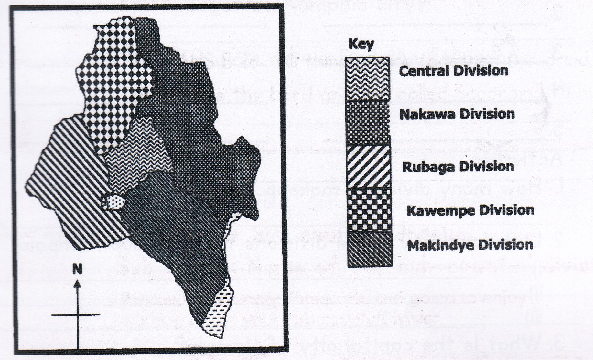

**Mention some important places found in Kampala city.**

1. Markets

2. Supermarkets

3. Museum

4. Parliamentary building

5. Banks

6. Main referral hospital

7. Statehouse

8. Main government offices.

**Name some hills found in Kampala**

1. Rubaga hill 5. Nsambya hill

2. Kololo hill 6. Makerere hill

3. Old Kampala hill 7. Muyenga hill

4. Mulago hill 8. Naguru hill

**Activity**

1. How many divisions make up Kampala?

2. List down any three divisions that make up Kampala.

i)

ii)

iii)

3. What is the capital city of Uganda?

4. Write KCCA in full.

5. List down three important places found in Kampala city.

i)

ii)

iii)

6. Identify any five hills which make up Kampala city.

i)

ii)

iii)

iv)

v)

7. What title is given to the political leader of a division?

8. Who is the lord mayor of Kampala city?

9. On which hill of Kampala do we find the following places?

i) Mulago hospital

ii) Makerere University

iii) State house

More practice (corrections)

***Score strip***

Name: _________________________________________

Date: __________________________________________

School: _________________________________________

Spellings Corrections

1. 1.

2. 2.

3. 3.

4. 4.

5. 5.

**LOCATION AND DIRECTIONS**

Location is a way of telling where things and places are found.

**How can you find the direction of places?**

By using the position of the sun

The sun rises from the East in the morning and sets to West in the evening.

2. **By using landmarks (Existing features ) like:**

1. Swamps 4. Streets

2. Valleys 5. Building etc

3. Lakes 6 Mountains

**For example**

1. Bank of Uganda is found along Kampala road.

2. Makerere University is found on Makerere hill

**3. By using compass direction.**

a) A compass is an instrument used to show direction of places.

**A compass**

Point to north

And point to south

Point to east

And point to the west

The sun rises in the east

And sets in the west

West is opposite the east

And north is opposite the south.

East on the right

And west on the left

North, south, east and west

Are main points on the compass?

b) A compass has four main points called **cardinal points / primary points.** These are:

i) North direction (**N**)

ii) East direction (**E**)

iii) West direction (**W**)

iv) South direction (**S**)

c) A compass needle faces the **North direction** when at rest.

d) A compass also shows other directions called Secondary

**Semi- cardinal points**, ARE;

i) North East direction (**NE**)

ii) South East direction (**SE**)

iii) South west direction (**SW**)

iv) North West direction (**NW**)

**4. By using shadows.**

1. In the morning, the shadow of an object is seen facing west direction.

2. And in the evening, the shadow of an object is seen facing East direction.

**Groups of people who use a compass direction in their daily life**

|  |  |
| --- | --- |
| 1. Pilots | 6. Soldiers (army) |
| 2. Mountains climbers | 7. Navigators |
| 3. Travelers | 8. Tourists |
| 4. Sailors | 9. Scouts and guides |
| 5. Surveyors | 10. Ship captains |

**Activity**

1. What is a compass?

2. What name is given to the four main points of a compass?

3. State any three ways of finding the direction of a place.

i)

ii)

iii)

4. In which direction does the compass needle face when at rest?

5. Mention any three groups of people who use a compass direction in their daily life.

i)

ii)

iii)

6. How is a compass direction useful to a tourist?

7. Draw a compass direction and name the four cardinal points.

8. Write the following in full.

**NE**

**SE**

**NW**

**SW**

9. In which direction does the sun;

i) rise?

ii) set?

10. Mention any two examples of semi cardinal secondary points

i)

ii)

More practice (corrections)

***Score strip***

Name: _________________________________________

Date: __________________________________________

School: _________________________________________

Spellings Corrections

1. 1.

2. 2.

3. 3.

4. 4.

5. 5.

**Maps and pictures**

There are two ways of representing objects on a paper.

* Drawing pictures
* Drawing maps

**A picture** is a drawing of an object as seen from a side.

**A map** is a drawing of an object drawn as seen from above.

The difference between a map and a picture is that a picture is drawn from a side while a map is drawn from above. Pictures are more detailed than a map.

The similarity between the two is that; they both represent real objects.

Both are drawings of objects.

|  |  |  |
| --- | --- | --- |
| **C:\Users\lg\Desktop\Prepositions\31bf7326ca4d08f3ab4356023349e31d.png** |  | **Image result for table images clip art** |
| A picture of a hat | **A picture of a tree** | **A picture of a table** |
|  |  |  |
| **A map of a hat** | **A map of a tree** | **A map of a table** |

Name: _________________________________________

Date: __________________________________________

School: _________________________________________

Spellings Corrections

1. 1.

2. 2.

3. 3.

4. 4.

5. 5.

**Activity**

1. What is a map?

2. What is a picture?

3. Give the difference between a map and a picture.

4. Let us draw the pictures and maps of these objects.

|  |  |  |
| --- | --- | --- |
| Object name | Picture | Map |
| tin |  |  |
| tree |  |  |
| ball |  |  |
| basket |  |  |
| house |  |  |
| chair |  |  |
| table |  |  |
| hut |  |  |
| pot |  |  |

***Score strip***



Checkup 1

Supervisor’s initial _____________

Score _____________________

Supervisor’s comment ___________________________

**PROJECT WORK**

1. With your teachers guidance draw a map of your school after taking its picture in your groups. Compare the picture and the map.

2. In your groups, using easily accessible materials, design a compass direction with the four cardinal points.

|  |  |  |  |  |
| --- | --- | --- | --- | --- |
| **WEEK** | **VALUE PROMISE** | **MEMORY VERSE** | **CHARACTER TRAITS** | **WORK HABIT** |
| **THREE** | “I will always be true and do the right things”. | 1st Timothy 4:12 | 1. Be of great integrity & dignity  2. Be truthful  3. Be genuine  4. Endurance & honesty  5. Be bold | Be gentle to all and stern to all |

1st Timothy 4:12 “Do not let anyone look down on you because you are young, but be an example for the believers in your speech your conduct, your love, faith and purity”.

Work habit

Name: _________________________________________

Date: __________________________________________

School: _________________________________________

Spellings Corrections

1. 1.

2. 2.

3. 3.

4. 4.

5. 5.

**Elements of a good map**

Title - Tells what the map is all about

Map key - gives the meaning of symbols used on a map

Map scale - measures the actual distances between - places on a map.

Compass - shows the direction of places on a map.

Boundary (frame or border) - encloses the map

*Elements on the map can also called qualities of a good map*

**Activity**

1. Why is the key important to the map?

2. How are these symbols important on the map?

3. State any three ways of finding the direction of a place.

i)

ii)

iii)

3. Which element of a map explains symbols?

4. Match the following correctly.

|  |  |
| --- | --- |
| Title | encloses the map |
| Key | tells what the map is about |
| Compass | measures actual distance. |
| Scale | explains the symbols of map |
| Boundary | shows direction of places. |

i) Title

ii) Key

iii) Compass

iv) Scale

v) Boundary

More practice (corrections)

***Score strip***

Name: _________________________________________

Date: __________________________________________

Spellings Corrections

1. 1.

2. 2.

3. 3.

4. 4.

5. 5.

**Symbols on a map**

Symbols are signs that represent real things and places on the map.

Symbols make reading a map easy. Things like swamps, bridges, rivers and forests can be represented by symbols on a map.

The symbols can always be explained in the key on the map.

**Examples of symbols used on maps of places.**

|  |  |
| --- | --- |
| River | Quarry |
| bridge | Mountain peak |
| Dam | Lake |
| railway | Swamps |
| Canal | Waterfall |
| Ferry | Church |
| Seasonal lake | Airport |
| hill | hospital |
| mine | factory |
| OW  well | mosque |
| Sch  C:\Users\Baby Class\Desktop\New folder (2)\Untitled.pngschool | forest |
| rift valley | 0 1 2    1cm 1km  scale |

**Activity**

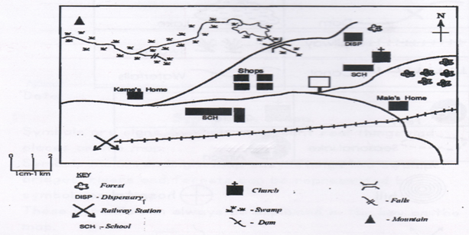**A map of Daniel’s village**

1. How many schools are shown on the map?

2. Whose house is near the forest?

3. How many houses are shown on this map?

4. Which element of the map explains what the symbols stand for?

5. Draw a map of your school. Use the symbols to represent things found around your school.

More practice (corrections)

**Quiz**

1. Which LC 1 member is in charge of children’s affairs?

2. Name part of an object that is seen on a map

3. In which position should one be in order to draw a map?

4. The four major points of a compass are called.

i)

ii)

iii)

iv)

5. Give one reason why a map should have a key.

6. What are map symbols?

7. Name two groups of people who use a compass.

i)

ii)

***Score strip***

Corrections

Name: _________________________________________

Date: __________________________________________

School: _________________________________________

Spellings Corrections

1. 1.

2. 2.

3. 3.

4. 4.

5. 5.

**PHYSICAL FEATURES IN OUR SUB-COUNT DIVISION**

What are physical features?

Physical features are land forms of an area.

**Examples of physical features**

|  |  |
| --- | --- |
| * Valleys | * Plains |
| * Mountains | * Swamps |
| * Plateaus | * Lakes |
| * Hills | * Rivers |

**Examples of physical features in Rubaga division**

|  |  |
| --- | --- |
| * Valleys | * Plains |
| * Plateaus | * Swamps |
| * Hills |  |

**Physical features** are divided into two, these are;

* Drainage features
* Relief features

**. Drainage features**

Drainage features are landforms which contain water in them.

**Examples of drainage features**

* Lakes
* Rivers
* Swamps
* Springs

**2. Relief features**

Relief features are landforms without water in them.

**Examples of relief features**

* Mountains
* Hills
* Plains
* Valleys
* Plateaus

**MOUNTAINS**

**What is a mountain?**

A mountain is a piece of land that rises very high above the surrounding land.

A series of connected mountains is **mountain ranges.**

A mountain peak is the highest point on the mountains.

**Examples of mountains and their peaks**

|  |  |
| --- | --- |
| **Mountains** | **Peak** |
| Mountain Rwenzori | Margherita |
| Mountain Elgon | Wagagai |
| Mountain Moroto | Sokodek |
| Mountains Mufumbiro | Muhavura |

**N.B Mountain Rwenzori** is the highest mountain in Uganda.

**How are mountains important to people?**

1. Mountains attract tourist who bring money to our country.

2. Mountains are homes of wild animals

3. Mountains help in the formation of rainfall.

4. Mountains are sources of some rivers.

5. Mountains have fertile soils good for farming.

6. Mountains are sources of some minerals.

7. Mountains are used for study purposes.

**Note:** The type of rainfall received mountains is called

**relief rainfall.**

**What problems do people who live on mountain slopes face?**

1. Mountainous areas make transport hard.

2. People face a problem of soil erosion when heavy rains come.

3. People face a problem of landslides especially during rainy season.

4. People are attacked by dangerous wild animals from mountains.

5. People face a problem of volcanic eruptions especially those living around active volcanic mountains.

**Activity**

1. A big piece of land high above the land around is called a

2. Mention any two examples of mountains you know.

i)

ii)

3. What do we call the highest point on the mountain?

4. Name the highest mountain in Uganda.

5. State any two uses of mountains to people.

i)

ii)

6. Mention any two disadvantages of mountains

i)

ii)

7. What are physical features?

8. are landforms of an area.

9. Write down any three examples of physical features.

i)

ii)

iii)

10. Mention any three examples of physical features in your sub-county.

i)

ii)

iii)

More practice (corrections)

***Score strip***

Name: _________________________________________

Date: __________________________________________

Spellings Corrections

1. 1.

2. 2.

3. 3.

4. 4.

5. 5.

Hills

**What is a hill?**

**A hill** is a piece of land higher than the land around it.

**Examples of hills found in Kampala city.**

|  |  |
| --- | --- |
| 1. Nakasero hill | 7. Kibuli hill |
| 2. Old Kampala | 8. Namirembe hill |
| 3. Makerere hill | 9. Makindye hill |
| 4. Kololo hill | 10. Mulago hill |
| 5. Muyenga hill | 11. Naguru hill |
| 6. Nsambya hill |  |

**How are hills useful found to people?**

1. People use hills for settlement.

2. People use hills for grazing their animals

3. Hills provide marrum for building roads.

4. Hills are used for growing crops.

5. Hills are sources of spring water.

6. They are used for building on school.

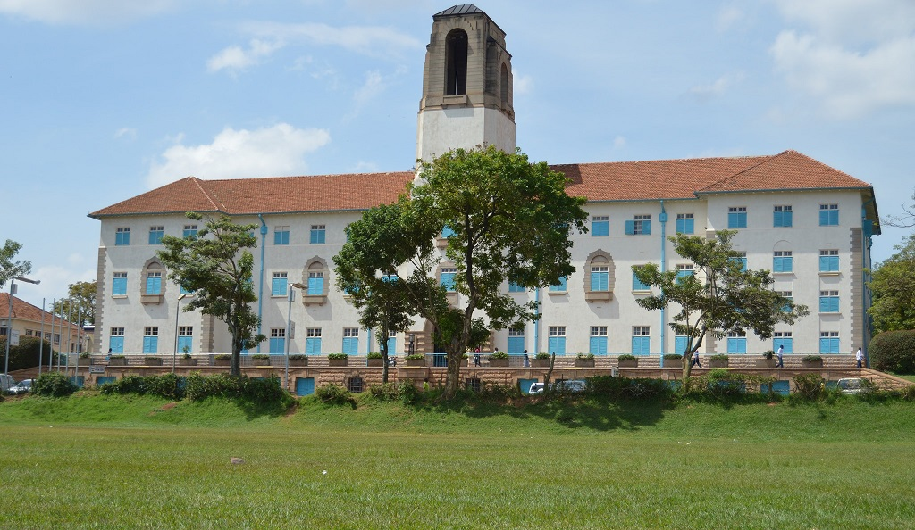

**What problems do people who live on hills face?**

1. There is soil erosion.

2. Hills make the construction of roads difficult.

3. There are landslides on some hills.

4. Some wrong doers hide around hills.

**What activities are done by people around hills?**

1. Tourism 3. Building roads and homes

2. Grazing animals 4. Mining e.g. stones

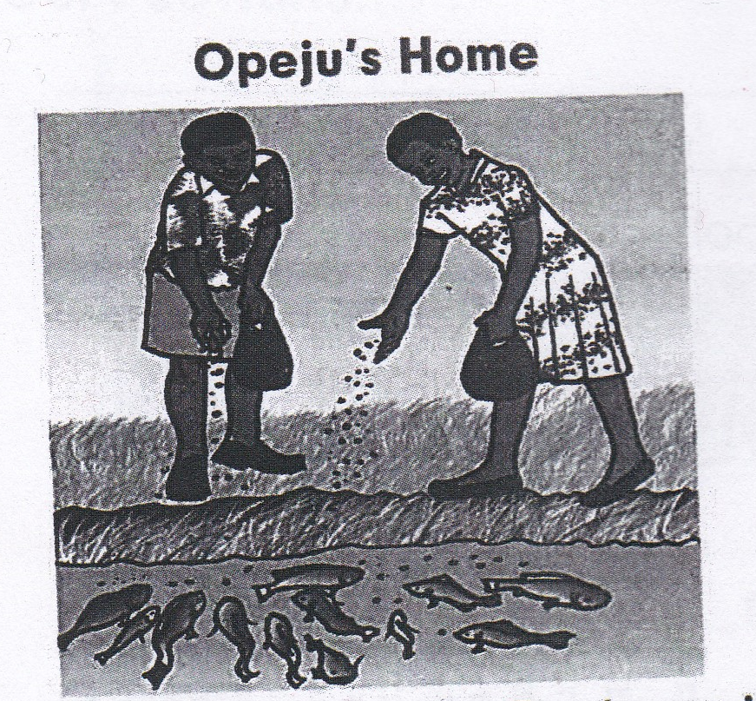

My name is Opeju. Our home is down the hills of Ogepa village. We have gardens down the valley and along the river. We planted yams and rice in them. My parents planted trees up the hills. These trees protect our house and crops from strong wind.

We also rear fish in two big ponds. My sister Azoyo and I help our parents to feed the fish. Sometimes we go across the road to fetch water from the well.

Our friend Nyiru lives up in the mountain. He says it is very cold up there. He usually brings us very sweet fruits from the mountain.

**Activity**

1. How do we call a small piece of land higher than the land around it?

2. Name any four hills on which Kampala is built.

i)

ii)

iii)

iv)

3. Write down the important places found on these hills.

i) Mulago hill

ii) Kibuli hill

iii) Old Kampala hill

iv) Rubaga hill

v) Namirembe hill

vi) Nsambya hill

4. State any two uses of hills to people.

i)

ii)

5. Give any three activities that can be carried out on hills.

i)

ii)

iii)

6. Mention any three disadvantages of hills.

i)

ii)

iii)

More practice (corrections)

***Score strip***



Checkup 2

Supervisor’s initial _____________

Score _____________

Supervisor’s comment ___________________________

**PROJECT WORK**

1. Through research in your groups and with the help of your teacher, find out the important places found at the different hills in Kampala.

2. Using the symbols you have learnt about in this week, design a map of your home area or school area using the learnt symbols. (It should include a title, a key and a boundary/frame)

|  |  |  |  |  |
| --- | --- | --- | --- | --- |
| **WEEK** | **VALUE PROMISE** | **MEMORY VERSE** | **CHARACTER TRAITS** | **WORK HABIT** |
| **FOUR** | “I choose to do what glorifies the Lord”. | Mathew 7:12 | 1. Be tender & considerate  2. Be loving  3. Be just & kind  4. Be truthful & peaceful  5. Avoid favoritism and being judgmental | Be kind whenever possible. It is always possible |

Mathew 7:12 “Do for others what you would wish them to do for you”.

Work habit

Name: _________________________________________

Date: __________________________________________

School: _________________________________________

Spellings Corrections

1. 1.

2. 2.

3. 3.

4. 4.

5. 5.

**VALLEYS**

**What is a valley?**

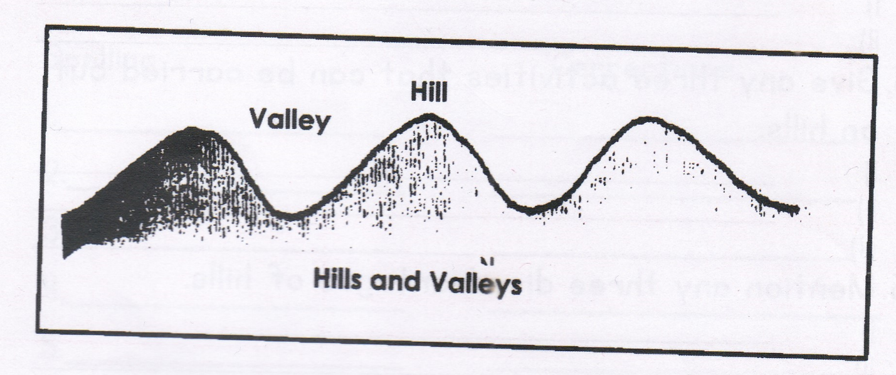A valley is a low land between two close hills or mountains

**Examples of valleys found in Kampala city.**

**1. Kitante valley 3. Bat valley**

**2. Nakivubo valley 4. Katanga valley etc**

**NB:** Lakes, rivers and swamps are found in valleys.

**How are valleys important to people?**

1. Valleys are sources of water.

2. Valleys have fertile soils good for crop growing

3. Sand and clay can be got from valleys.

4. Brick making is done in valleys.

5. Valleys are sources of some rivers and streams.

6. Fishing is done in some valleys.

7. Papyrus for crafts and buildings can be got from valleys.

**Disadvantages of valleys**

* Valleys act as hiding places for wild animals.
* Valleys make road construction difficult.
* Valleys encourage flooding.
* Valleys are habitats for dangerous wild life.

**Activity**

1. What is a valley?

2. Mention any two examples of valleys found in our district.

i)

ii)

3. Mention any three uses of valleys to the people.

i)

ii)

iii)

4. Name the important feature / places found on these valleys.

i) Bat valley

ii) Nakivubo valley

iii) Kitante valley

5. Name the physical feature labeled x.

X

More practice (corrections)

***Score strip***

Name: _________________________________________

Date: __________________________________________

School: _________________________________________

Spellings Corrections

1. 1.

2. 2.

3. 3.

4. 4.

5. 5.

**PLATEAUS**

**What is a plateau?**

A plateau is a raised flat topped piece of land. A plateau can be found on a hill. It is also called a table land.

**PLAINS**

**What is a plain?**

A plain is a low flat land.

**Importances of plateaus**

* **P**eople build houses on plateaus.
* People graze animals on plateaus.
* People grow crops on plateaus.
* Plateaus attract tourists who bring income.

**Disadvantages of plateaus**

* They encourage floods.
* Some plateaus have seasonal water sources.
* Plateaus are homes of many wild animals.

**Economic activities done on a plateau**

* Animal rearing
* Crop growing
* Fishing
* Tourism
* Hunting

**SWAMPS**

**What is a swamp?**

**A swamp** is a water logged area with vegetation**.**

Another name for swamps is marshes or wetlands.

**Why are swamps important to people?**

1. Swamps provide papyrus for making crafts.

2. Swamps help in the formation of rainfall.

3. Swamps are sources of water for domestic use.

4. Swamps provide people with fish.

5. People get clay from swamps.

6. People grow crops like yams, rice and sugarcane in swamps.

7. Swamps are homes for aquatic animals.

**Why are swamps important to people?**

1. These are vectors that spread diseases like mosquitoes

2. The area can easily flood when heavy rains occur

3. People can be attacked by wild animals that live in swamps.

4. Water in swampy areas weakens buildings.

5. People can experience coldness especially at night.

**Examples of plants grown in swamps**

* Rice
* Yams
* Sugarcanes

**Activity**

1. is a water logged area with vegetation.

2. State three crops that can be grown in the swamps.

i)

ii)

iii)

3. W rite down any three importance’s of the swamps.

i)

ii)

iii)

4. Name two land materials that can be get from swamps.

i)

ii)

5. Mention two problems faced by people living in swampy areas.

i)

ii)

6. What is a plateau?

7. What name is given to a low flat land?

More practice (corrections)

***Score strip***

Name: _________________________________________

Date: __________________________________________

School: _________________________________________

Spellings Corrections

1. 1.

2. 2.

3. 3.

4. 4.

5. 5.

**LAKES AND RIVERS**

**What is a lake?**

A lake is a mass of water a basin/ lowland.

**Some lake found in Uganda.**

1. Lake Victoria

2. Lake George

3. Lake Katwe (provides salt)

4. Lake Kyoga (the swampiest lake in Uganda)

5. Lake Wamala

6. Lake Bunyonyi (the deepest lake in Uganda)

7. Lake Albert

8. Kabaka’s lake (man-made lake found in Kampala)

**Lake Victoria** is the biggest lake in Uganda.

The manmade lake found in Kampala is called Kabaka’s lake. It is found in Rubaga division.

**What is a river?**

A river is a mass of water flowing in a channel.

**Some rivers found in Uganda.**

1. River Nile (The longest river in Uganda)

2. River Mpongo

3. River Mayanja

4. River Unyama

5. River Kwania

6. River Achwa

**NB:** Lakes and rivers form **convectional rainfall.**

**How are lakes and rivers important to people?**

1. They help in the formation of rainfall.

2. They provide people with water.

3. They are used for transport.

4. They provide people with fish.

5. They provide people with sand.

6. They provide people with shells.

7. People generate hydro- electricity from rivers.

8. Some lakes provide salt like **Lake Katwe.**

9. They are used for recreation e.g swimming and boat racing.

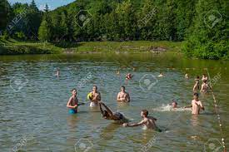

**Examples of some types of fish cough in lakes and rivers**

1. Tilapia (commonest fish) 4. Mud fish

2. Silver fish 5. Lung fish etc

3. Nile perch (biggest fish)

**Mention some methods of catching fish.**

1. By using fishing nets. 3. By using a basket

2. By using hooks 4. By using spears

**Ways of preserving fish (keeping fish for a long time)**

1. By tinning or canning 4. By smocking

2. By sun drying 5. By refrigerating

3. By salting

**Activities done around lakes and rivers**

1. Farming 4. Brick laying

2. Fishing (main activity) 5. Pottery

3. Mining e.g. sand and salt 6. Water transport

**What problems are faced by people living near lakes and rivers?**

1.Drowning especially young children

2. Over fishing e.g. fishing young fish.

3. Throwing dirty things in lakes which makes water dirty.

4. Water hyacinth makes fishing and transport difficult

5. Dirty water from lakes causes diseases like cholera, typhoid and dysentery.

6. Over flooding especially during the rainy season.

7. Dangerous animals from water bodies kill people e.g. crocodiles, snakes and hippos.

**Activity**

1. Name the biggest lake in Uganda.

2. Which lake in Uganda gives us salt?

3. Mention any three examples of lakes in Uganda.

i)

ii)

iii)

4. What name is given to a mass of flowing water?

5. Write down any two examples of rivers in Uganda.

i)

ii)

6. Name the longest river in Uganda.

7. Mention any two activities that can be carried out around lakes and rivers.

i)

ii)

8. State any three importances of lakes and rivers.

i)

ii)

iii)

9. Write down any two diseases caused by dirty water from lakes and rivers.

i)

ii)

10. Mention any three disadvantages of lakes and rivers

i)

ii)

iii)

11. Name the deepest lake in Uganda.

12. Name one manmade lake in Kampala.

13. Which type of rainfall is received around lakes and rivers?

More practice (corrections)

***Score strip***

Name: _________________________________________

Date: __________________________________________

School: _________________________________________

Spellings Corrections

1. 1.

2. 2.

3. 3.

4. 4.

5. 5.

**Topical questions**

**1.** What are physical features?

2. Write down the types of land forms found in your sub-county.

i)

ii)

iii)

3. Names any other landforms that are found in valleys.

4. What activities can be carried out in swampy areas?

i)

ii)

iii)

iv)

5. Why is it not good to build houses in swampy areas?

6. What types of food can we get from rivers and lakes?

7. Name one person who uses each of the following in his/her work.

a) clay

b) Sand

8. Write the problems which may be faced by people who live in hilly lands.

i)

ii)

iii)

iv)

9. What is the biggest lake in Uganda?

10. Which lake in Uganda gives us salt?

11. Write two things people use for fishing in Uganda.

i)

ii)

12. How do people preserve fish in Uganda?

i)

ii)

iii)

iv)

13. Give two reasons why many farmers like to put their farms near lake and rivers.

i)

ii)

14. Mention any two uses of lakes to people in your sub-county.

i)

ii)

15. Identify three local methods of locating places.

in hilly lands.

i)

ii)

iii)

16. Where does the sun rise from?

17. Write down four people who use a compass in their day to day activities.

i)

ii)

iii)

iv)

More practice (corrections)

***Score strip***

 Checkup 3

Supervisor’s initial ______________

Score _____________________

Supervisor’s comment ___________________________

**PROJECT WORK**

1. In Uganda, we have many physical features in our environment. When you are at home, identify the physical features in the area and their uses to your community. If there are disadvantages you can also list them down.

2. Using the compass direction you had made earlier, use it to find different directions (North, South, East, West e.t.c) in your area.

|  |  |  |  |  |
| --- | --- | --- | --- | --- |
| **WEEK** | **VALUE PROMISE** | **MEMORY VERSE** | **CHARACTER TRAITS** | **WORK HABIT** |
| **FIVE** | “I will always do good to others the way I want them to do for me”. | Proverbs 31: 25 | 1. Be strong and of great dignity  2. Do not be fearful  3. Always work without ceasing  4. Rejoice in the lord and be thankful.  5. Be helpful | Believe you can and you’re halfway there |

Proverbs 31: 25 “She is strong and of dignity; she is not afraid of the future”.

Work habit

Name: _________________________________________

Date: __________________________________________

School: _________________________________________

Spellings Corrections

1. 1.

2. 2.

3. 3.

4. 4.

5. 5.

**Some of the new words we have learnt.**

|  |  |
| --- | --- |
| Word | Meaning |
| 1. Sub-county division | Is an area made-up of parishes and villages. |
| 2. Parish | Is a group of villages. |
| 3. County | Is an area made-up of a sub-county. |
| 4. Village | Is an area made up of different homes. |
| 5. District | Is an area made up of counties. |
| 6. Country | Is an area made up of districts. |
| 7. Mayor | Is a person who heads a division or sub-country. |
| 8. Compass | Is an instrument used to show direction of places. |
| 9. Compass direction/ compass rose | Is an element of a good map used to show direction of places. |
| 10. Land marks | Are existing features in an area. |
| 11. Cardinal points | Are the four main / major points of a compass. |
| 12. Picture | Is a drawing of an object as seen from aside. |
| 13. Map | Is a drawing of an object as seen from above. |
| 14. Physical features | Are natural land forms of an area. |
| 15. Mountain | Is a piece of land that rises very high above the surrounding land. |
| 16. Mountain peak | Is the highest point on a mountain. |
| 17. Hill | Is a piece of land that rises slightly above the surrounding land. |
| 18. Valley | Is a low land between two hills/ mountains. |
| 19. Plain | Is a low flat land. |
| 20. Plateau | Is a raised flat topped piece of land. |
| 21. Swamp | Is a water logged area with vegetation. |
| 22. Lake | Is a mass of water in a basin/ lowland. |
| 23. River | Is a mass of flowing water. |

Quiz

1. Give the political importance of physical features.

2. How do we call the land between two hills and mountains?

3. Give another name used to mean physical features.

4. Name the physical feature that covers the largest part of a sub country.

5. Give two physical features that help in rainfall formation.

i)

ii)

6. State the economic importance of physical features.

7. Give one major economic activity done on a plateau.

8. Give another name of a swamp.

Name: _________________________________________

Date: __________________________________________

School: ________________________________________

Spellings Corrections

1. 1.

2. 2.

3. 3.

4. 4.

5. 5.

**THEME 2: LIVELIHOOD IN OUR SUB-COUNTY DIVISION**

**People in our sub-county / division**

There are different groups of people in our sub-county division.

These groups are called **Ethnic groups.**

**What is an Ethnic group?**

An ethnic group is a group of people who share the same origin and almost speak the same language.

**The table shows the ethnic group and their tribes with the language they speak.**

|  |  |  |  |
| --- | --- | --- | --- |
| **Ethnic group** | **Origin** | **Tribe** | **Language** |
| Bantu | Cameroon highlands | Baganda  Banyankore  Basoga  Bakiga  Banyoro  Batooro  Bagwere  Basamya | Luganda  Runyankore  Lusoga  Rukiga  Runyoro  Rutooro  Lugwere  Lusamya |
| Nilotics | Bahr-el Ghazal | Langi  Acholi  Alur  Japadhola  Iteso | Langi  Acholi  Alur  Adhola/ Ludaama  Ateso |
| Nilo-Hamites | Ethiopia | Kumam  Karamajong  Sabiny | Kuma  Akaramong  sabiny |
| Hamites | Ethiopia | Batusi  Bahima | Kinyarwanda  Runyankore |

**Activity**

1. What is an ethnic group?

2. What does the word “ntu” mean?

3. Name the main occupation of Bantu.

4. Name the largest ethnic group in your sub-county.

5. Mention the main four ethnic groups in your sub-county.

day activities.

i)

ii)

iii)

iv)

6. To which ethnic group do the Baganda belong?

7. Write down any two tribes under the Nilotics.

i)

ii)

8. Give the languages spoken by the following tribes.

i)

ii)

iii)

iv)

9. What is the smallest ethnic group in Uganda?

10. State two activities carried out by the Nilotics.

i)

ii)

More practice (corrections)

***Score strip***

Name: _________________________________________

Date: __________________________________________

Spellings Corrections

1. 1.

2. 2.

3. 3.

4. 4.

5. 5.

**People’s culture in our sub-county / division**

**What is culture?**

Culture is the way people behave in a particular society.

**What is a tribe?**

A **tribe** is a group of people who have the same ancestors and speak the same language.

**Examples of people’s culture**

1. Birth of a child. 5. Entertainment

2. Birth of twins 6. Burial ceremony

3. Marriage 7. Ways of dressing

4. Circumcision

**Birth of a child**

1. Relatives and friends bring gifts for the baby.

2. The grandfather gives a name to the baby.

3. The baby belongs to the father’s clan.

4. A feast is held to welcome the baby in the family.

**Birth of twins**

Parents get special name e.g. in Buganda, father Ssalongo and mother Nnalongo.

Twins get special names e.g in Buganda, Kigogo is born before twins and Kiiza follows twins.

|  |  |  |
| --- | --- | --- |
| **Twins**  Boy and boy  Boy and girl  Girl and boy  Girl and girl | **Elder twin**  Wasswa/Kakuru  Wasswa/Kakuru  Babirye/Nyangoma  Babirye/Nyangoma | **Younger twin**  Kato  Nakato/Nyakato  Kato  Nakato/Nyakato |

**Marriage customs**

1. A boy or a girl cannot marry any of their relatives

2. A man with his relatives and friends visit the family of the woman.

3. The introduction ceremony (Kwanjula/Okwanjura) is held.

4. They take a lot of gifts/bride price to the woman’s family.

5. The woman is taken for marriage by her aunt and brother.

6. The brother (muko) of the woman is given a cock on the wedding day

7. Both families join and make cerebrations. There is a lot of eating, drinking and dancing.

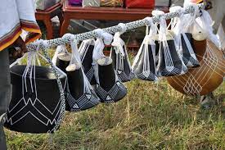

**NB: Bride price are the things taken to a woman’s family by a man**

**Activity**

1. What is culture?

2. What name is given to the way people in a particular society behave?

3. What is a tribe?

4. Mention any three examples of people’s culture.

i)

ii)

iii)

5. Which tribe in Uganda is commonly known for circumcision?

6. What special name is given to the father of twins?

7. What name is given to the things taken to a woman’s family by a man?

8. Give any two names given to twins.

i)

ii)

9. Who gives a name to new born child / baby in a family?

10. Give the difference between culture and a tribe.

More practice (corrections)

***Score strip***

Name: _________________________________________

Date: __________________________________________

School: _________________________________________

Spellings Corrections

1. 1.

2. 2.

3. 3.

4. 4.

5. 5.

**Circumcision**

**Which tribe practices circumcision in Uganda?**

1. Bagisu

2. Bakonjo

3. Sabiny (practice female genital mutilation)

**Circumcision of the girls**

1. Girls of 15-18years are circumcised by women.

2. Doctors found out that it is not good to circumcise girls

3. Today few girls are circumcised.

**Circumcision of boys**

1. Boys and girls dance Imbalu dance (Bagisu tribe).

2. After circumcision, the boy becomes a man. He can now get a wife to marry.

3. He can speak in family and in village meetings.

**Burial ceremony**

1. When person dies, friends, relatives and in-laws feel sad.

2. People come to mourn.

3. Long ago mourners used to bring tobacco before the coming of money.

4. Today people bring money, firewood and food.

5. Before burial the money brought is called **mabugo** (in Buganda)

6. It is used to buy bark cloth to wrap the dead body plus other clothes

When the body is buried, the money the mourners bring is called Amataaba (in Buganda)

**The last funeral rites**

Relatives, friends and in-laws come together to remember the death of their dear one.

**1.They serve food and drinks**

**2. They show the heir.**

**3. They say bye-bye to the dead.**

**Why do people hold the last funeral ceremony?**

1. To show the heir.

2. To send away death from the family

3. To say bye-bye to the dead.

**Activity**

1. Mention any two tribes which carry out circumcision.

i)

ii)

2. Which tribe in Uganda carries out genital/mutilation (female circumcision)?

3. Which tribe in Uganda carries out Imbalu dance?

4. How does a boy become a man in Bagisu tribe?

5. Mention any three things brought by people during the burial ceremony.

i)

ii)

iii)

6. Identify any two activities carried out in the last funeral rites.

i)

ii)

7. Give two reasons why people carry out the last funeral rites.

i)

ii)

More practice (corrections)

***Score strip***

Name: _________________________________________

Date: __________________________________________

Spellings Corrections

1. 1.

2. 2.

3. 3.

4. 4.

5. 5.

**Entertainment**

1. Tribes have dances and folk songs

2. These are accompanied by different musical instruments.

3. Instruments are followed by drumming and clapping of hands.

**Examples of local musical instruments**

1. Drum (Engoma) 4. Horn (Engombe)

2. African flute (Omulere) 5. Bow-harp (Adungu)

3. Long drum (Engalabi) 6. Xylophone (Amadinda)

**Each tribe has got its dance.**

|  |  |
| --- | --- |
| **Tribe** | **Dance** |
| **Baganda** | _ Bakisimba  _ Amagunju (danced for the Kabaka)  _ Muwogola |
| **Basoga** | _ Tamenaibuga  _ Irongo  _ Nalufuka |
| **Bakiga** | _ Ekizino |
| **Bagisu** | _ Imbalu |
| **Batooro** | _ Orunyege |
| **Acholi** | _ Ding ding |
| **Banyankore** | _ Ekitagururo |

**Dressing**

**Common clothes in our sub-county / division**

|  |  |
| --- | --- |
| **Men’s wear** | **Women’s wear** |
| shirts | skirts |
| Vests | blouses |
| Coats | Dresses |
| Trousers | Gomesi |
| Shorts | Shoes |

**N.B**

**1. The traditional wear for Baganda men is Kanzu.**

**2. The Banyankore women wear Busuuti.**

**3. The Karimojong women wear beads around their waists and necks.**

|  |
| --- |
| C:\Users\LG COMPUTERS\Desktop\DEBORAH\LESSONS\kanzu & gomesi.jpg |
| Baganda wearing Gomesi and kanzu |

**Why do people wear clothes?**

1. To cover their bodies.

2. To look smart.

3. For easy identification.

4. Clothes show people’s culture.

5. Clothes bring unity among people.

6. To keep warm.

**Activity**

1. Mention any three examples of musical instruments

i)

ii)

iii)

2. Match the following tribes to their dances

|  |  |
| --- | --- |
| Tribe | Dances |
| Baganda | Ekitagururo |
| Bakiga | Imbalu |
| Batooro | Muwogola |
| Basoga | Orunyege |
| Acholi | Ekizino |
| Banyankore | Irongo |
| Bagisu | Ekitagururo |

i) Baganda

ii) Bakiga

iii) Batooro

iv) Basoga

v) Acholi

vi) Banyankore

vii) Bagisu

3. What name is given to the dance danced by the Baganda for the king?

4. Give any two reasons why people sing.

i)

ii)

5. Name the cultural wears of the following tribes.

|  |  |  |
| --- | --- | --- |
| **Tribe** | **Men** | **Women** |
| Baganda | _____________ | ____________ |
| Banyankole | _____________ | ____________ |
| Basoga | _____________ | ____________ |

6. Identify any two reasons why people wear clothes.

i)

ii)

More practice (corrections)

***Score strip***

 Checkup 4

Supervisor’s initial _____________

Score ___________________

Supervisor’s comment ___________________________

**PROJECT WORK**

We all have different cultures because of our different backgrounds, however we must learn to respect each others’ cultures always.

Research and find out more about your different cultures e.g. about staple food, norms, dressing, social behaviour and ways of living. You can ask your teacher, parents or guardians for help. Present the work in written form and give it to the teacher.

|  |  |  |  |  |
| --- | --- | --- | --- | --- |
| **WEEK** | **VALUE PROMISE** | **MEMORY VERSE** | **CHARACTER TRAITS** | **WORK HABIT** |
| **SIX** | “I choose to impact other people’s lives positively”. | Exodus 20:12 | 1. Be respectful & obedient  2. Always appreciate your parents  3. Be a good listener  4. Be proud of your parents  5. Always respect and listen to your parents | Always do your best, What you plant now, you will harvest later |

Exodus 20:12 “Respect your father and your mother so that you may live a long time in the land that I am giving you”.

Work habit

Name: _________________________________________

Date: __________________________________________

School: _________________________________________

Spellings Corrections

1. 1.

2. 2.

3. 3.

4. 4.

5. 5.

**SELF TESTING EXERCISE**

1. What is an ethnic group?

2. What does the word “ntu” means?

3. Name the main occupation of the Bantu.

4. Why is it good to name a new born child?

5. How do we call the following people in Buganda?

a) Father of twins

b) Mother of twins

6. Which ethnic group used a drum as their main musical instruments?

7. Why is it good to have the last funeral rites in a family?

8. Write the dance performed by the following

a) Bagisu

b) Baganda

9. Why should people wear clothes? (Give three reasons)

i)

ii)

iii)

10. What is the traditional wear for Baganda?

a) Men

b) Women

More practice (corrections)

***Score strip***

Quiz

1. What is a tribe?

2. A person who lived many years ago in the family is called?

3. Give the origins of the following ethnic groups

i) Bantu

ii) Hamites

iii) Nilo-hamites

iv) Nilotics

4. is a group of people under one forefather.

5. Mention any one example of a totem.

**Some of the new words we have learnt.**

|  |  |
| --- | --- |
| Word | Meaning |
| 1. ethnic group | Is a group of people who have the same origin and almost speak the same language |
| 2. culture | Is the way how people behave in a particular society |
| 3. tribe | Is a group of people who have the same origin and speak the same language |
| 4. marriage | Is a union of man and woman as husband and wife |
| 5. circumcision | Is the removal of the fore skin of the penis for culture, religious or health issues |
| 6. entertainment | An activity that is diverting and holds attention. |
| 7. burial | Is the ritual placing a corpse in a grave. |
| 8. clan | Is a group of people under the same forefather |
| 9. funeral | A ceremony at which a dead person is buried. |
| 10. funeral rites | A ceremony at which a dead person is remembered. |

Name: ­­­­_________________________________________

Date: ­­­­_________________________________________

School: _________________________________________

Spellings Corrections

1. 1.

2. 2.

3. 3.

4. 4.

5. 5.

**Leadership in our sub-county/ division**

Who is a leader?

A leader is a person entrusted with power to guide and control others.

**Types of leaders found in our division.**

1. Civic leaders 5. Voluntary leaders

2. Political leaders

3. Cultural / traditional leaders

4. Religious leaders

**Examples of cultural leaders**

1. Kabaka Ronald Muwenda Mutebi ll of Buganda.

2. Kyabazinga of Busoga

3. Omugabe of Ankole

4. Omukama Solomon Gafabusa of Bunyoro

5. Omukama Oyo Nyimba Kabamba Iguru of Tooro

6. Emorimor Isuban of Iteso

7. Rwot of Acholi

**Religious leaders**

These lead people in different religions.

**Examples of religious leaders.**

1. Bishops 5. Imam

2. Nuns 6. Pastors

3. Reverends 7. Sheikhs

4. Fathers 8. Arch Bishop

**Political leaders**

These include; RDC, RCC, prime minister, President, MPs etc

|  |
| --- |
| E:\museveni.jpg |
| President Museveni is a political leader |

**Qualities of a good leader**

A leader is a person who guides people. Examples of leaders in our country include the President, members of parliament, pastors, head teachers, teachers, class prefects and others.

Below is Mr. Tumbo and Mr. Ching Chang. They are contesting

to represent Bora constituency in parliament. The following are their qualities. Whom would you vote for?

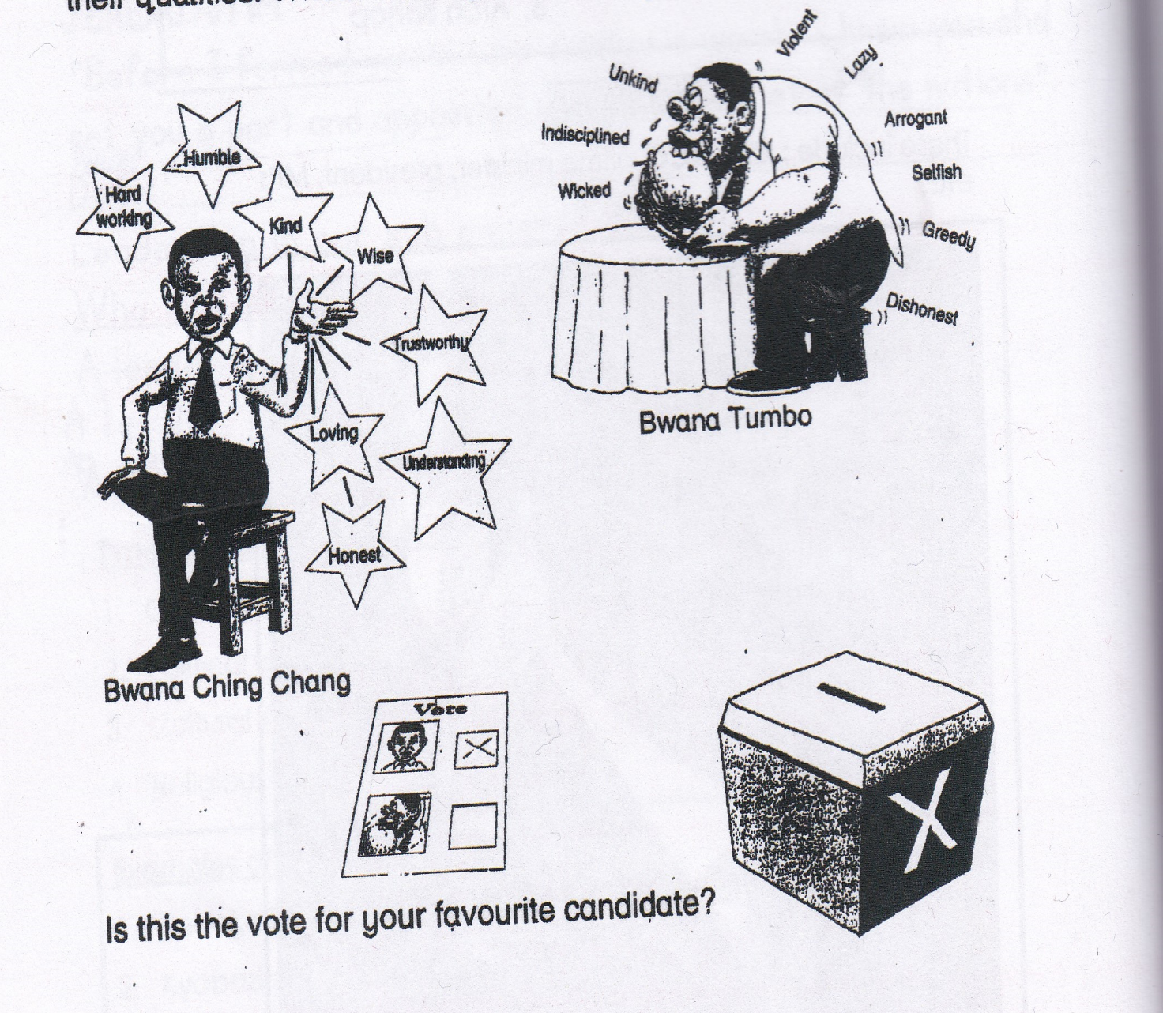

**Activity**

1. Who is a leader?

2. State any three types of leaders.

i)

ii)

iii)

3. Give any two examples of cultural leaders.

i)

ii)

4. What title is given to the Buganda cultural leader?

5. Mention any two examples of political leaders.

i)

ii)

6. Who is the current president of Uganda?

7. Who is the current mayor of Rubaga division?

8. List down any two examples of religious leaders.

i)

ii)

9. Write the following in full.

i) RDC

ii) RCC

iii)MP

10. Give the titles given to the following cultural leaders of;

i) Busoga

ii) Ankole

iii) Bunyoro

iv) Iteso

v) Acholi

11. Mention any three qualities of a good leader.

i)

ii)

iii)

**Corrections**

***Score strip***

Name: _________________________________________

Date: __________________________________________

School: _________________________________________

Spellings Corrections

1. 1.

2. 2.

3. 3.

4. 4.

5. 5.

**The local council committee**

The local council committee in short is LC.

**Members of the local council committee.**

There are 10 members on the local committees.

|  |  |
| --- | --- |
| **Post** | **Duties** |
| The chairperson | i)Heads the local council.  ii)Chairs the committee and council meetings.  iii)Signs all official documents  iv)Settles disputes and supervises all other members. |
| The vice chairperson | i) Is in charge of children affairs  ii) Takes over the chairperson’s duties when he / she is absent. |
| Secretary for finance | i) He/she is the treasurer of the council |
| Secretary for information, education and mobilization | i) passes on all information required by the people. |
| Secretary for youth and development Education | i) Mobilizes the youth to participate in co-curricular activities |
| The general secretary meetings | i) Records all minutes to participate in co-curricular activities  ii) Keeps the official records / documents and files |
| Secretary for security | i) Maintains peace and security in the area |
| Secretary for the disabled | i) Mobilizes people with disabilities for development. |
| Secretary for women and public heath | i) She is in charge of women affairs and public health. |
| Secretary for production and Environmental protection. | i) He / she promotes economic production  ii) He / she encourages environment protection in the area. |

**Activity**

1. Which local council member is responsible for children?

2. Write LC in full.

3. How many members make up the local council committee?

4. Write down the role of the chairperson of a local council.

5. Name the member of a local council who is responsible for people with disabilities.

6. What is the role of the secretary for women and public health?

More practice (corrections)

***Score strip***

Name: _________________________________________

Date: __________________________________________

School: _________________________________________

Spellings Corrections

1. 1.

2. 2.

3. 3.

4. 4.

5. 5.

**How are leaders important to people?**

1. Leaders help people to live and work in peace.

2. Leaders encourage people to work hard.

3. Leaders teach people their responsibilities.

4. Leaders settle disputes among people.

5. Leaders plan for development in an area.

**Laws that govern people.**

Leaders make laws that people have to obey to be able to live peacefully.

Examples of laws that govern people.

1. Do not take drugs. 4. Do not abuse others.

2. Do not steal. 5. Do not fight.

3. Keep peace and order. 6. Do not mistreat others

**Acts people do that break laws.**

1. Trespassing 5. Murdering

2. Raping 6. Defilement

3. Stealing (theft) 7. Assault

4. Drug abuse.

**Note**: people who break the laws are punished.

They are judged from courts by the judges and magistrates.

**Examples of punishments.**

1. Beating 4. Death sentence

2. Imprisonment 5. Community cleaning

3. Paying a fine

**People who enforce (keep) law and order.**

1. Police officer 4. Local council leaders

2. Judges 5. Magistrates

3. Prison officers

**Activity**

**1.** State any two roles of leaders.

i)

ii)

2. Write down any two acts of law breakers.

i)

ii)

3. List down any three punishments that can be given to law breakers.

i)

ii)

iii)

4. Mention any three groups of people who enforce law and order.

i)

ii)

iii)

5. Identify any three importances of leaders to people.

i)

ii)

iii)

6. List down any three examples of laws that govern people.

i)

ii)

iii)

**SELF TESTING EXERCISE**

1. Who is a leader?

2. How many members form a local council committee?

3. Which member of the local council is in charge of children affairs?

4. Who heads the local council committee?

5. Why do we need leaders in our division?

6. Who is the king of the following kingdoms?

i) Buganda

ii)Tooro

iii)Bunyoro

7. Which type of leader is a prime minister?

8. How does the police enforce law and order?

More practice (corrections)

***Score strip***



Checkup 5

Supervisor’s initial _____________

Score _____________________

Supervisor’s comment ___________________________

Quiz

1. How do we call people who practice cultural leadership?

2. How do the following leaders come to power?

a) Cultural leaders

b) Political leaders

c) Civil leaders

d) Religious leaders

3. Give any three roles of religious leaders in your sub-county.

i)

ii)

iii)

4. Give the title given to the king of Bunyoro.

5. Name the members in the local council committee responsible for security.

6. State any three qualities of a good leader.

i)

ii)

iii)

7. What title is given to the political head of a town council?

**PROJECT WORK**

In this week, you have learnt about local councils and their duties. Make a role play of all the duties of the different people that form the local council. The project should be done under the guidance of your teacher as a class. The role play should be for about 30 minutes.

|  |  |  |  |  |
| --- | --- | --- | --- | --- |
| **WEEK** | **VALUE PROMISE** | **MEMORY VERSE** | **CHARACTER TRAITS** | **WORK HABIT** |
| **SEVEN** | “I choose to be at peace and have good team work”. | Psalm 127:3-5 | 1. Be responsible  2. Be God fearing  3. Be compassionate to your children  4. Be obedient & respect for children  5. Cherish the glory of your children | Discipline is the bridge between goals and accomplishment |

Psalm 127:3-5 “Children are a gift from the lord, they are a real blessing like arrows in the hands of a warrior, are children born in one’s youth”.

Work habit

Name: _________________________________________

Date: __________________________________________

School: _________________________________________

Spellings Corrections

1. 1.

2. 2.

3. 3.

4. 4.

5. 5.

Some of the new words we have learnt.

|  |  |
| --- | --- |
| Word | Meaning |
| 1. leader | Is a person who guides others |
| 2. leadership | Is an act of guiding others |
| 3. civic leaders | Are leaders appointed by the government to guide others |
| 4. political leaders | Are leaders that are elected by people. |
| 5. religious leaders | Are leaders that preach the word of God. |
| 6. cultural leaders | Are leaders who inherit power. |
| 7. inherit | Is to obtain something after the death of someone. |
| 8. RDC | Resident District Commissioner |
| 9. RCC | Resident City Commissioner |
| 10. MP | Member of parliament. |
| 11. C. A. O | Chief Administrative Officer |
| 12. Hard working | Is to put more effort on doing something. |
| 13. humble | Not being arrogant of prideful. |
| 14. Kind | Is having a tender, considerate and helpful nature. |
| 15. wise | Is having wisdom of something. |
| 16. trustworthy | Is taking responsibility for one’s conduct and obligation. |
| 17. loving | Is feeling/ showing love or affection. |
| 18. D. E. O | District Education Officer |
| 19. D. H.O | District Health Officer |
| 20. D. P. C | District Police Commander |
| 21. understanding | Is the capacity of rational thought about something. |
| 22. honest | Is worthy of being depended on. |
| 23. Defilement | Is having sex with someone below the age of 18 years |
| 24. raping | Is a forced sex |
| 25. trespassing | Is entry to another person’s property without permission. |
| 26. Murdering | Is to killing intentionally. |
| 27. imprisonment | Is to put someone in prison/ jail as a lawful punishment |
| 28. assault | Is attempted / threatening physical attack by someone who appears to be able to cause bad harm if not stopped. |

Name: _________________________________________

Date: __________________________________________

School: **________________________________________**

Spellings Corrections

1. 1.

2. 2.

3. 3.

4. 4.

5. 5.

**Economic activities in our sub-county / division**

**What are economic activities?**

Economic activities are the activities done by people to get money.

**Examples of works people do (Economic activities)**

1. Brick making 6. Weaving 11. Farming, etc

2. Pottery 7. Stone mining 12. Trading

3. Teaching 8. Sewing

4. Welding 9. Carpentry

5. Fishing 10. Tailoring

**Pottery**

Pottery is the making of pots. A person who makes pots is called **a potter**.

**Uses of pots**

1. Pots keep drinking water

2. Pots are used for cooking food

3. Pots are used for fetching water.

4. Pots are used for decorations.

5. Pots are sold to get money.

**Weaving**

**Weaving** is the making of things local materials.

Things using local materials.

Things made out of local materials are called handcrafts.

**Pictures of people making handcrafts**

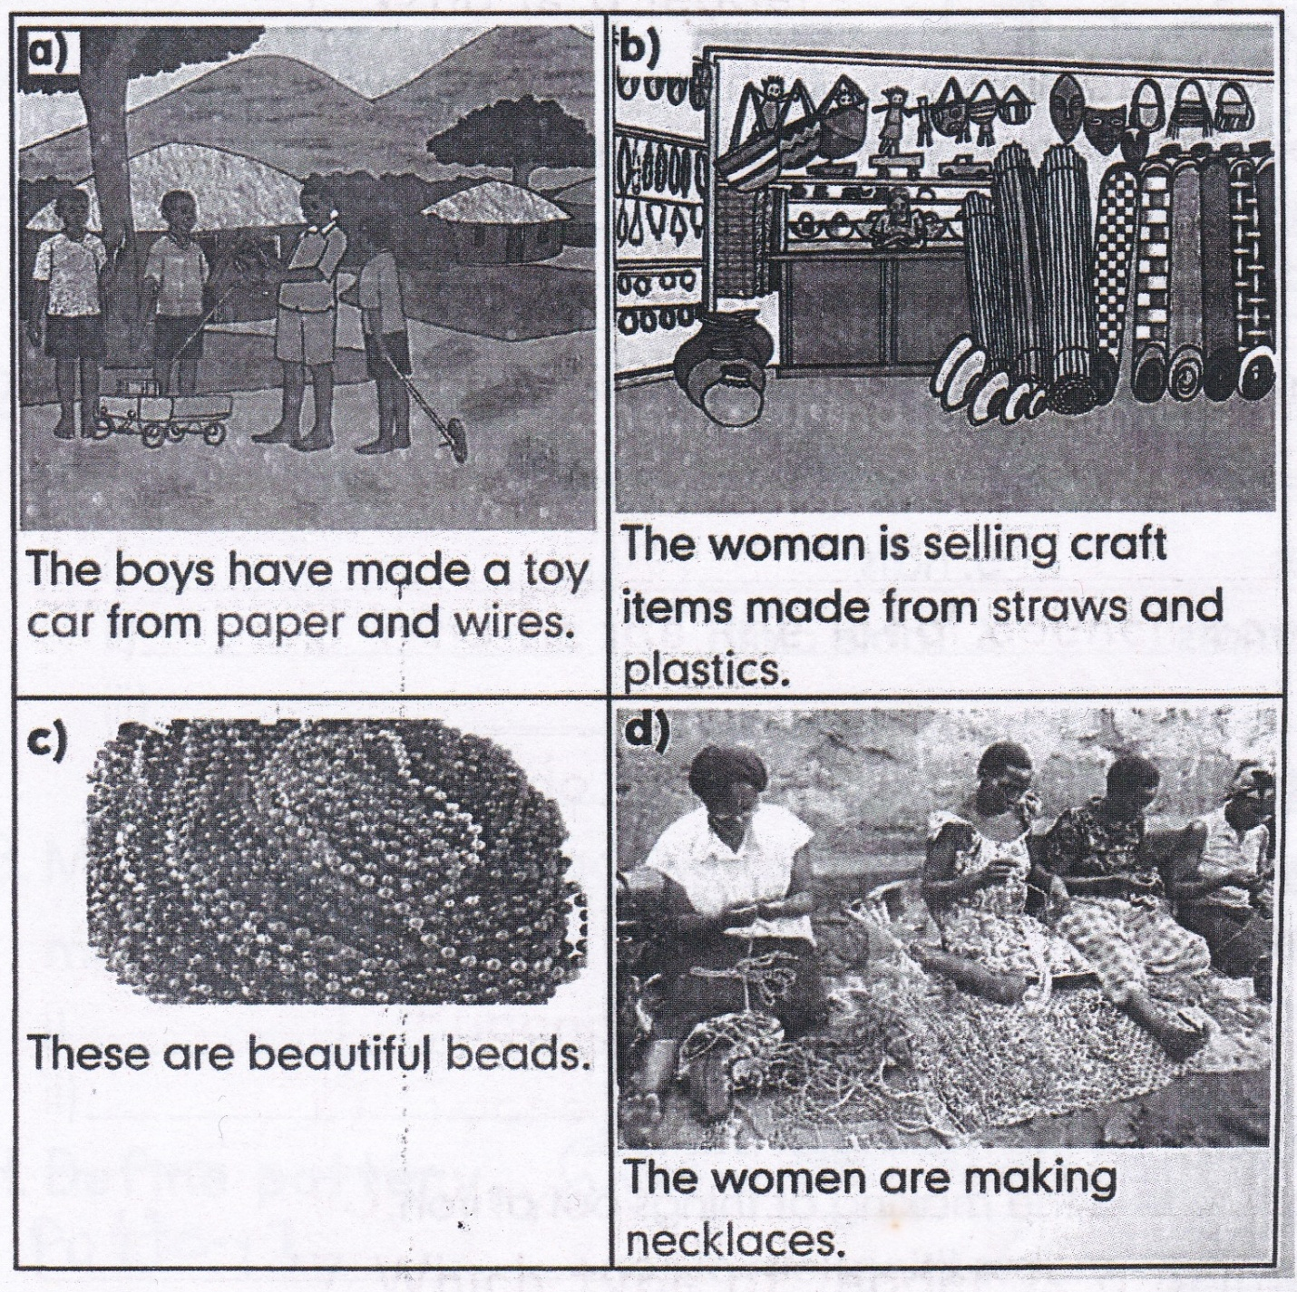

PICTURE MISSING

**Things done in weaving.**

1. Basket 4. Mat 7. Stools

2. Ropes 5. Hats

3. Door mats 6. Table cloth

**Materials used in weaving are:**

1. Raffia 4. Sisal etc

2. Papyrus 5. Cained reeds

3. Banana fibers 6. Palm leaves

**Basketry** is the making of baskets.

**Smithing:** is the making of things out of iron.

**A blacksmith:** makes things out of iron.

**Things made out of iron**

a) Knives c) Hoe e) Arrowheads g) Nails

b) Pangas d) Axe f) Padlocks h) Doors etc.

**Activity**

1. What are economic activities?

2. Write down any four examples of economic activities in our-county.

i)

ii)

iii)

iv)

3. Mention any two activities people do to get money.

i)

ii)

4. Give the meaning of the word pottery.

5. What name is given to person who makes things to person make things out of clay?

6. Name any local material used in pottery.

7. Give any three uses of pots.

i)

ii)

iii)

8. What are handcrafts?

9. is the making of things out of local materials.

10. Mention any three examples of handcrafts.

i)

ii)

iii)

11. State any three local materials used in weaving.

i)

ii)

iii)

12. Give the difference between smithing and basketry.

13. What name is given to a person who makes things out of iron?

14. Who is a black smith?

15. Write down any five things made out of iron.

i)

ii)

iii)

iv)

v)

More practice (corrections)

***Score strip***

Name: _________________________________________

Date: __________________________________________

School: **_________________________________________**

Spellings Corrections

1. 1.

2. 2.

3. 3.

4. 4.

5. 5.

**Farming**

This is the growing of crops and rearing of animals.

The different types of farming are:

Subsistence farming, mixed farming, poultry farming,

Dairy farming, ranch farming and bee keeping.

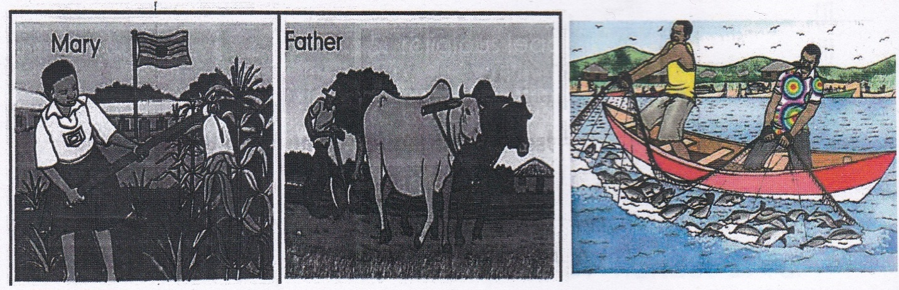

N.B-Subsistence farming is the growing of crops and rearing of animals for home use.

* Mixed farming is the growing of crops and rearing of animals on the same piece of land.
* Poultry is the rearing of domestic birds.
* Ranch farming is the rearing of cattle for meat production.
* Dairy farming is the rearing of cattle for milk production
* Bee keeping is the rearing of bees.

**Things a farmer needs to do to start farming.**

|  |  |
| --- | --- |
| * Capital /money | * Garden tools |
| * Labour | * Transport |
| * Market | * Land |

Matia planted a little tree

The little tree grew into a big tree

The big tree produced fruits for Matia to eat.

Matia looked after the big tree

The big tree had big branches,

The big branches provided firewood

For Matia and his friends to cook food.

Matia liked the big tree.

The big tree had big leaves.

The big leaves provided shade

For Matia and his friends to rest in.

**Robert**

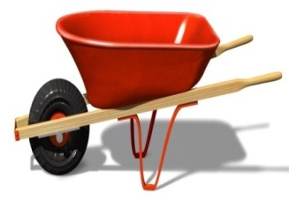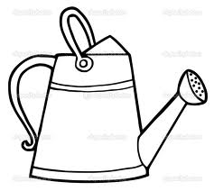**Examples of garden stools.**

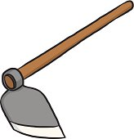

C:\Documents and Settings\esther\Local Settings\Temporary Internet Files\Content.IE5\30TEQDAG\MC900340376[2].wmf Hoe watering can wheelbarrow

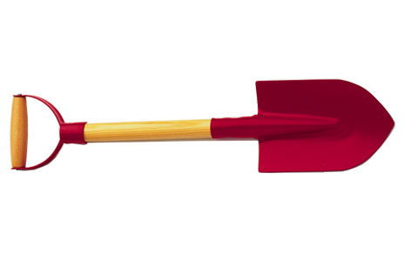dglxasset[1]

Rake panga spade

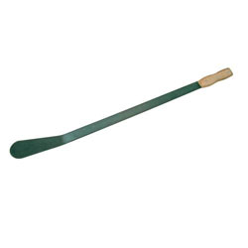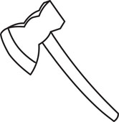

slasher axe

**Activity**

1. How do we call the growing of crops and rearing of animals for home use?

2. What is farming?

3. State any two types of farming.

i)

ii)

4. is the growing of crops and rearing of animals on the same piece of land.

5. Write down any three needs of a farmer.

i)

ii)

iii)

6. Mention any three problems faced by farmers when doing their work.

i)

ii)

iii)

7. Write down any three examples of garden tools.

i)

ii)

iii)

More practice (corrections)

***Score strip***

Name: _________________________________________

Date: __________________________________________

School: **_________________________________________**

Spellings Corrections

1. 1.

2. 2.

3. 3.

4. 4.

5. 5.

**Self-test exercise**

1. Write down any two importances of economic activities.

i)

ii)

2. Match people to their work.

|  |  |
| --- | --- |
| Sewing | fisherman |
| Teaching | potter |
| Nursing | tailor |
| Carpentry | farmer |
| Pottery | nurse |
| Fishing | teacher |
| Farming | carpenter |

3. Write down the places of work for these people

Teacher

Carpenter

Farmer

Doctor

4. What is pottery?

5. Who is a blacksmith?

6. Name some two crops that are used as local raw material in factories.

i)

ii)

7. Write down four things that are made at a carpentry shop.

i)

ii)

iii)

iv)

8. Why do people work so hard in your sub-county?

9. What are economic activities?

10. Identify any four examples of economic activities.

i)

ii)

iii)

iv)

11. is the growing of crops and rearing of animals

12. What is trading?

More practice (corrections)

***Score strip***

**Quiz**

1. Name two economic activities you know.

i)

ii)

2. Name the economic activity carried out by most people in your village.

3. State two problems aced by people at work.

i)

ii)

4. How do we call any work done by people to earn money?

5. How do we call things made out clay soil?

6. What is carpentry?

7. Name the place where a barber works.

Name: _________________________________________

Date: __________________________________________

School: **________________________________________**

Spellings Corrections

1. 1.

2. 2.

3. 3.

4. 4.

5. 5.

**Social services**

Social services are services the government or non –governmental organization provides to people for a better living.

**Examples of social services**

* Education services
* Banking
* Electricity supply
* Health services
* Water supply
* Market services
* Security services
* Communication

**Education services**

**What is education?**

Education is the process of getting knowledge, skills and values.

People mainly get education from schools.

**TYPES (LEVELS) OF SCHOOLS**

1. Nursery schools

2. Primary schools

3. Secondary schools

4. University

5. Colleges

6. Technical schools

**Note: There two types of education which include;**

i) Formal education (Got from school)

ii) Informal education (Got from home)

**N.B**

1. The **DEO** (District Education Officer) heads all schools in a district.

2. The Ministry of Education and Sports (**MOEs)** heads all schools in Uganda.

3. The Minister of Education and Sports is responsible for all schools in Uganda.

**How is Education important to people in Uganda?**

1. Education provides employment (jobs) to people.

2. Education helps people to learn to read and write.

3. People learn skills from Education.

4. Education is the source of knowledge for people.

**NB:** The highest level of Education is a **University.**

Primary seven pupils sit for **Primary Leaving Examinations** (PLE) to be promoted to secondary school level. The **Uganda National Examination Board (UNEB)** prepares national examinations for primary and secondary schools.

The government pays school fees for children who are in government schools through its program called **Universal**

**Primary Education (UPE) and Universal Secondary Education (USE)**

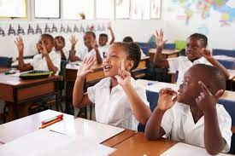

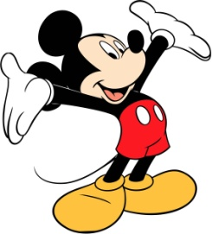

**Read the dialogue below between Agnes and Barbra.**

Agnes: What does your mother do?

Barbra: She teaches children at school.

Agnes: Where does she teach?

Barbra: She teaches at Carson School.

Agnes: Teaching is a good job.

Barbra: That’s why mother is proud of it.

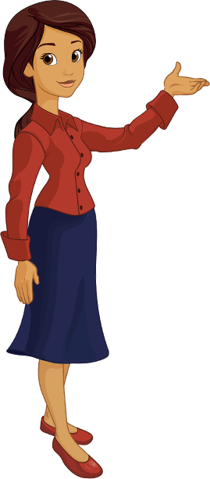

**Activity**

1. What are social services?

2. Write down any four examples of social services.

i)

ii)

iii)

iv)

3. Write the following in full.

a) UNEB

b) UPE

c) PLE

d) MOEs

e) DEO

4. Under which ministry do we find all schools in Uganda?

5. Define socials services.

6. Who is the current Minister of Education and Sports in Uganda?

7. Identify one problem facing education in Uganda

8. Why do people go to school? (Give two reasons)

i)

ii)

More practice (corrections)

***Score strip***



Checkup 6

Supervisor’s initial _____________

Score _____________________

Supervisor’s comment ___________________________

**PROJECT WORK**

In your groups, make hand crafts of your choice and present them to your teacher.

|  |  |  |  |
| --- | --- | --- | --- |
| **WEEK** | **VALUE**  **PROMISE** | **MEMORY**  **VERSE** | **CHARACTER**  **TRAITS** |
| **EIGHT** | “I choose to be unique in everything that I do”. | Ephesians 2: 19 | 1. Self esteem  2. Honest  3. Love  4. Servant leadership  5. Patience |

**Ephesians 2:19** “I am no longer a stranger but a fellow citizen with God’s people as a member of god’s household built on a firm foundation of apostles and prophets with Christ Jesus himself as the chief cornerstone.

Name: _________________________________________

Date: __________________________________________

Spellings Corrections

1. 1.

2. 2.

3. 3.

4. 4.

5. 5.

**Health services**

Health services are provided by giving medical care.

Places which provide health services include;

1. Hospitals 3. Dispensaries

2. Clinics 4. Health centers

The main national referral hospital in Uganda is **Mulago hospital**

**Ways in which medical care is provided.**

1. Injections 4. Drips

2. Creams 5. Syrups

3. Using lotions 6. Tablets

Examples of common hospitals

|  |  |
| --- | --- |
| * Mulago hospital | * Kibuli hospital |
| * Mengo hospital | * Nsambya hospital |
| * Lubaga hospital |  |

**People who provide medical care**

|  |  |
| --- | --- |
| 1.. Doctors | Treat sick people |
| 2. Nurse | Care for sick people. |
| 3. Opticians | Sell eye glasses |
| 4. Dentist | Treats sick teeth |
| 5. Surgeons | Operate on people. |
| 6. Midwives | Care for pregnant women. |
| 7. Health inspector | Teachers people how to live in a clean Environment and how to stay healthy |
| 8. Oculist | Treats sick eyes |

**N.B**. 1. The Ministry of Health controls all places that provide medical services.

2. The minister of Health heads all places that provide medical services.

**Activity**

1. Write down any two places where health services are provided.

i)

ii)

2. Name some two examples of common hospitals in Uganda.

i)

ii)

3. Why do people go to the hospital?

4. Match these people who provide medical services to their services.

|  |  |
| --- | --- |
| Doctor | Sell eye glasses |
| Nurses | Care for pregnant woman. |
| Opticians | Treat sick eyes |
| Dentist | Care for sick |
| Midwives | Treat sick people |
| Oculist | Treats sick teeth |

5. Name the main national referral hospital

6. State any three ways medical care is provided.

i)

ii)

iii)

7. Which ministry controls all medical facilities in out sub-county?

More practice (corrections)

***Score strip***

Name: _________________________________________

Date: __________________________________________

School: _________________________________________

Spellings Corrections

1. 1.

2. 2.

3. 3.

4. 4.

5. 5.

**Security services**

**What is security?**

**Security** is the way of protecting people and their property against danger.

Security services are rendered to people to protect them with their property.

**Organs which provide security**

1. The police

2. Army

3. Private security organs

4. Prison

5. Local defence unit (LDUs)

**Weapons**

**What is a weapon?**

A weapon is a material which is used to defend ourselves from enemies.

**Examples of weapons**

1. Guns

2. Batons 5. Tear gas

3. Sticks 6. Bombs etc

4. Bow and arrow 7. Land mines

**The Police Force**

The police in Uganda is divided into sections:

**These are:**

1. Dog section

2. Anti riot police

3. Military police

4. Mobile Patrol police.

5. Criminal Intelligence Investigation Department (CllD)

6. Ant-smuggling unit

7. Fire Brigade

8. Passport Police Section

9. Traffic police.

**N.B**

**1. Inspector General of Police:** Is the title given to the head of the Uganda police.

2. The police in under the Ministry of **Internal affairs.**

3. The person who heads a police station is called an **Officer in charge**

**Duties of each section of police**

|  |  |
| --- | --- |
| Section | Duty |
| 1. Dog section | * Tracing the criminals |
| 2. Anti riot police | * For stopping riots |
| 3. Traffic police | * For controlling traffic flow * Enforcing traffic rules |
| 4. Police patrols | * Responsible for enforcing order in the communities |
| 5. The criminal intelligence investigation Department | * Responsible for finding out criminals (law breakers) |
| 6. Fire brigade | * For putting out fire. |

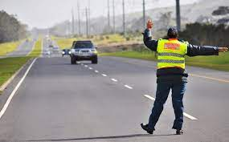

**What is the role of police?**

1. To protect suspects from mob justice.

2. To control traffic flow.

3. To put out fire.

5. To keep suspects.

6. To investigate crimes.

7. To enforce law and order in the community.

8. To protect people’s life and property.

**Activity**

1. In which ministry is the Uganda Police?

2. What is the main work of the Uganda Police?

3. Which section of the Uganda police controls vehicles on the road?

4. Who is the current inspector General of police?

5. What is a weapon?

More practice (corrections)

***Score strip***

Name: _________________________________________

Date: __________________________________________

School: _________________________________________

Spellings Corrections

1. 1.

2. 2.

3. 3.

4. 4.

5. 5.

**The Army**

1. The army protects the lives of people and their property in the county.

2. The title given to the head of the army is a **Commander in Chief.**

3. The Uganda People’s Defence Force (UPDF) is the name for the Uganda Army.

**Roles / duties of the Army**

1. The army fights protects the country.

2. The army fights against foreign invaders (rebels)

3. The army entertains people (army band)

**Note: 1.** The people who work in the army are called **soldiers**

**2.** Soldiers live in barracks in houses called **unipots.**

**The Prison**

The prison is a place where law breakers are kept in safe custody.

**Roles of the prisons**

1. It keeps law breakers in safe custody.

2. It changes law breakers into law abiding citizens.

3. It punishes law breakers.

Prisoners are taught different skills like

1. Carpentry 4. Craft making

2. Music 5. Digging etc

3. Sports

**Prisoners are taken to the courts of law for judgment.**

Children below 18 years are taken to special places like:

* Kampiringisa prisons
* Naguru remand home
* Bugungu reformatory school

**Private security organs**

1. These are privately owned security groups.

2. They help the police to keep law and order.

**Examples of private security groups in Uganda**

1. Uganda securico 5. Delta force

2. Saracen 6. Hash

3. Group 4 7. Securex etc

4. KK security

**Activity**

1. What is the work of Uganda Police force?

2. Which section of Uganda Police force controls vehicles on the roads?

3. Who is the current inspector general of police?

4. What is a weapon?

5. Mention any two examples of weapons.

i)

ii)

6. Write in full.

i) UPF

ii) UPDF

7. The people who work in the army are called

8. What is security?

9. Mention any two organs which provide security.

i)

ii)

10. State any three examples of weapons.

i)

ii)

iii)

11. Give any two sections under police.

i)

ii)

12. What title is given to the head of Uganda Police?

13. In which ministry is the police?

14. Who heads a police station?

15. Mention the duties of each section below.

i) Dog section

ii) Traffic police

iii) Anti-riot police

iv) Police patrols

v) Fire brigade

More practice (corrections)

***Score strip***

Name: _________________________________________

Date: __________________________________________

School: _________________________________________

Spellings Corrections

1. 1.

2. 2.

3. 3.

4. 4.

5. 5.

**Transport services**

Transport is the movement of people, goods and services from one place to another

**Types of transport**

There are four types of transport namely:

* Road transport
* Water transport
* Air transport
* Railway transport

**Road transport**

Road transport is the commonest type of transport it is used in almost every part of the community.

**Means of road transport**

|  |  |  |  |
| --- | --- | --- | --- |
|  |  |  |  |
| bicycle | car | truck | pickup |
|  |  |  |  |
| motorcycle | lorry | coach |  |

**Types of roads**

1. Tarmac roads

2. Feeder roads

3. Murram roads

**Why is road transport the commonest type of transport used by people?**

1. It is cheap

2. It offers door to door services.

3. It is available.

4. It enables people to each many places

**Problems of using road transport.**

1. These is a lot of traffic jam along the road.

2. There are high risks of accidents.

3. There is a lot of dust on roads during dry weather.

**Air Transport**

People move by air using air transport.

**Means of air transport**

1. Aero planes 4. Rockets

2. Parachutes 5. Air balloons

3. Helicopter 6. Air ship

**N.B**

1. Aeroplanes land at **airports.**

2. The biggest airport in Uganda is **Entebbe International Airport.** (used by many airplanes from all over the word)

3. **A run way** is a road at the airport for aero planes.

4. Aero planes’ park is a **prone.**

5. **A pilot** flies an airplane.

6. Small aircrafts land at **airstrips** and **air fields.**

**Examples of air strips in Uganda**

1. Soroti airstrip. 4. Kimaka airstrip

2. Gulu airstrip. 5. Mbarara airstrip

3. Arua airstrips 6. Kajjansi airstrip

**N.B**

**1.** Air transport is the quickest type of transport.

2. It is the suitable type of transport for perishable goods.

3. It is the most expensive type of transport.

4. It is not common.

**Water transport**

People move on water when using water transport.

**Means of water transport.**

1. Boats 3. Canoes

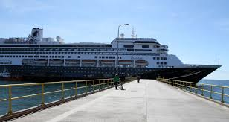2. Ships 4. Ferry

**N.B**

1. Ferries are big water vessels which carry many people and bulky goods e.g. (cars buses) etc.

2. Water transport is both the slowest and cheapest type of transport.

3. It is the most suitable type of transport for bulky (heavy) goods.

4. A ship captain sails a ship.

5. Water transport is good for people who live on islands.

**RAILWAY TRANSPORT**

People move on rails when using railway transport.

**Means of railway transport.**

1. Train

2. Tram

*A train stops at a railway station.*

**Kinds of trains**

a. Passenger train - for carrying people

b. Cargo train – for carrying cargo / luggage

**NB**

1. A train is timetabled (moves and stops on time)

2. It is good for bulky goods.

3. It carries many people.

**How is transport useful to people?**

1. Transport helps people to do work easily.

2. Transport helps people to move from one place another.

3. Transport helps people to carry their goods.

**Activity**

1. What is transport?

2. Which is main airport in Uganda?

3. What is the quickest type of transport?

4. Why is road transport the commonest type of transport used by people?

5. How is transport useful to people?

6. Write the people who operate the following means of transport.

i) Cars

ii) Ship

iii) Aeroplanes

7. Write down the means of transport for each of the following.

a. Road transport

b. Air transport

c. Water transport

d. Railway transport

**8. Match these means of transport to their parks.**

|  |  |
| --- | --- |
| i. Aero plane | Landing site |
| ii. Buses | Taxi park |
| iii. Train | Airport |
| iv. Taxi | Railway station |
| v. ships and boats | Bus park |

9. What type of transport is used on lakes and rivers?

More practice (corrections)

***Score strip***

 Checkup 7

Supervisor’s initial _____________

Score _____________________

Supervisor’s comment ___________________________

**PROJECT WORK**

Using practical skills make a design sample of three different types of transport (road, water and air). Each group should make one type of transport but not all. After making the types of transport, as a whole class design railway transport practically.

All the types should be made practically as hand work.

|  |  |  |  |
| --- | --- | --- | --- |
| **WEEK** | **VALUE**  **PROMISE** | **MEMORY**  **VERSE** | **CHARACTER**  **TRAITS** |
| **NINE** | “I believe God gives me wisdom”. | John 8 : 32 | 1. Truth  2. Honesty  3. Faithfulness  4. Self-control |

**John 8:32 “**And you will know the truth and the truth shall set you free.

Name: _________________________________________

Date: __________________________________________

Spellings Corrections

1. 1.

2. 2.

3. 3.

4. 4.

5. 5.

**Communication services**

**What is communication?**

Communication is the sending and receiving of messages. (information).

**There are two types of communication.**

a. Verbal communication

b. Non- verbal communication.

**Means of communication**

**Local communication**

Local communication is the sending and receiving of messages using local means.

**Means of local / traditional means of communication**

1. Drums 5. xylophones

2. Clapping 6. Horns

3. Bells 7. Mouth (talking)

4. Whistles 8. Gestures

**Importance of using local communication**

1. It is cheap to use.

2. It is easy to use.

**Problems of using local communications**

1. It might not reach many people at the same time.

2. It wastes time.

3. The message may change as it moves from one messenger to another.

**NB: Gestures** are signs used in communication without talking. It is mostly used by dumb people.

**Modern communication**

Modern communication is the sending and receiving of messages using modern means.

**Means of modern communication**

1. Radios 6. Magazines

2. Television 7. Letters

3. Phones 8. Fax

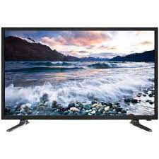4. Newspapers 9. Computers

5. Internet 10. Post office

**Importance of modern means of communication**

1. It saves times

2. The message does not change.

3. The message can reach intended recipients at the same time.

**Problems of using modern means of communication**

1. It is very expensive.

2. It requires people who have gone to school.

3. Some of it requires electricity to be used.

**Post office (P.0)**

**What is a post office?**

A post office is a place where people post and receive their letters from.

**How is a post office important to people?**

1. It provides employment to people

2. It provides postage stamps to people.

3. It takes people’s letters and parcels to different places.

**Museum**

**What is a museum?**

A museum is a place where things of long ago are kept.

**Of what importance is a museum to people?**

1. It preserves things of long ago.

2. It is used for study purposes.

3. It provides information about things of long ago to people.

4. It provides employment to people.

5. It attracts tourists who bring money to our country.

**Activity**

1. What is communication?

2. Write down four means of local / tradition communication.

i)

ii)

iii)

iv)

3. Mention four means of modern communication.

i)

ii)

iii)

iv)

4. Write P.O in full.

5. Which means of communication do the dumb and deaf people use?

6. Name the place where people take and receive letters from.

7. What is a museum?

8. Give two importances of a museum to people in our sub-county.

i)

ii)

10. What is a post office?

More practice (corrections)

***Score strip***

Name: _________________________________________

Date: __________________________________________

School: _________________________________________

Spellings Corrections

1. 1.

2. 2.

3. 3.

4. 4.

5. 5.

**Problems people face when getting social services.**

* Lack of enough trained teachers in some schools.
* Corruption / bribery.
* Embezzlement of founds
* Lack of enough medical workers.
* Lack of enough medicine in hospitals
* Poor roads.
* Traffic jam

**Solutions to the problem s of social services**

* By punishing corrupt officials.
* By preparing roads with potholes.
* By constructing better road.
* By registering more trained teachers.
* By recruiting more medical workers.

**Activity**

1. Identify any two problems people faced when getting social services.

i)

ii)

2. Write down two solutions to the problems people face when getting services.

i)

ii)

3. Define social services

4. Mention any four examples of social services

i)

ii)

iii)

iv)

5. Why are their few people who use air transport?

6. Why are children taken to school?

7. Name two organs that provide security in the community.

i)

ii)

8. What is communication?

9. Name four means of communication used by people in your sub-county.

i)

ii)

iii)

iv)

10. How many members make up a local council committee?

11. If someone steals your hen, where should you take him or her after he/she has been caught?

12. What is the role of the police?

13. Why do people go to hospital?

14. What is transport?

15. Why is road transport the commonest type of transport used by people?

16. How is transport useful to people?

17. How do we call a special car used to carry patients to the hospital?

18. Write the following in full.

a. P.O

b. O.C

c. UPDF

d. UPF

e. UPE

f. UNEB

g. CIID

19. What name is given to the Uganda Army?

20. Name the biggest hospital in Uganda.

21. What name is given to a place where small aeroplanes land?

Quiz

1. Name the social services got from school.

2. State two types of roads you know.

i)

ii)

3. How do we call the person who treats our teeth?

4. Where do we find the international airport of Uganda?

5. Name two sections of police.

i)

ii)

6. How do we call a place where people post and receive letters?

7. What services do teachers give?

More practice (corrections)

***Score strip***

**Some of new words we have learnt.**

|  |  |
| --- | --- |
| Word | Meaning |
| 1. Economic activities | Are activities done to get money |
| 2. Pottery | Is the making of things out of clay |
| 3. Welding | Is the fastening two or more pieces of material together by softening with heat. |
| 4. Fishing | Is the act of catching fish from water bodies |
| 5. Weaving | Is the making of things using local materials. |
| 6. mining | Is an act of extracting minerals from underground. |
| 7. sewing | Is joining or attaching pieces of clothes using a needle and threads. |
| 8. carpenter | Is a person who makes things out of wood/timber. |
| 9. basketry | Is the making of baskets |
| 10.smithing | Is making things out of iron |
| 11. Blacksmithing | Is a person who makes things out of iron |
| 12. farming | Is the growing of crops and rearing of animals. |
| 13. Trading | Is the buying and selling of goods. |
| 14. Social services | Are services the government provide to people for a better living. |
| 15. Education | Is the getting of knowledge and skills |
| 16. security | Is the way of protecting people and their property against danger. |
| 17. insecurity | Is a state of being subject to danger. |
| 18.transport | Is the movement of people, goods and services from one place to another. |
| 19. communication | Is the sending and receiving of messages. |
| 20. weapon | Is a material which is used to defend ourselves from enemies |
| 21. Corruption | Is the use of a position of trust for dishonest gains. |
| 22. Embezzlement | Is the use of someone’s funds or property for your own good benefit |

***Score strip***



Checkup 8

Supervisor’s initial _____________

Score ___________________

Supervisor’s comment _____________________________

**PROJECT WORK**

1. In your groups, make 2 communication devices that you have learnt about with local materials in the environment.

2. Play a game using gestures as a way of communication in your class. Make written sentences and then translate them into gesture language (signs) and ask the class what you have said.